**RECURSOS PARA EL PROYECTO 2**

**Hacer el piano:** [**https://www.youtube.com/watch?v=nWCRCwB3kfg**](https://www.youtube.com/watch?v=nWCRCwB3kfg)

[**https://www.freecodecamp.org/espanol/news/como-construir-un-teclado-how-to-build-a-piano-keyboard-using-vanilla-javascript/**](https://www.freecodecamp.org/espanol/news/como-construir-un-teclado-how-to-build-a-piano-keyboard-using-vanilla-javascript/)

**Bateria:**[**https://github.com/musicandcode/drumkit?fbclid=IwAR2VyHfY6xo-3PD1UbNpcxNkCnH7SEVMc-lIjJAAj4a1BkDvbiRWGBJlzi8**](https://github.com/musicandcode/drumkit?fbclid=IwAR2VyHfY6xo-3PD1UbNpcxNkCnH7SEVMc-lIjJAAj4a1BkDvbiRWGBJlzi8)

**Sonidos instrumentos:** [**http://www.sonidosmp3gratis.com/**](http://www.sonidosmp3gratis.com/)

**Imágenes:** [**https://www.freepik.com/**](https://www.freepik.com/)

**Iconos:** [**https://www.flaticon.es/**](https://www.flaticon.es/)

**Curso Piano:** [**https://www.youtube.com/watch?list=PLipiKg9R84AaoxqBY4Pe9wvGgSDLkXkJ-&time_continue=2&v=mtGIt1X1q3E&feature=emb_logo**](https://www.youtube.com/watch?list=PLipiKg9R84AaoxqBY4Pe9wvGgSDLkXkJ-&time_continue=2&v=mtGIt1X1q3E&feature=emb_logo)

**Curso Bateria:** [**https://www.youtube.com/watch?v=8BO0WTO7BxY&list=PLuTZXbjKO1Q6iCebyJ4oUByqHVZYg2MH5**](https://www.youtube.com/watch?v=8BO0WTO7BxY&list=PLuTZXbjKO1Q6iCebyJ4oUByqHVZYg2MH5)

**Tipografía:**

**font-family: 'Sedgwick Ave', cursive;**

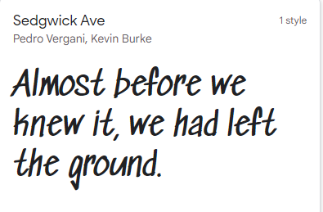

**font-family: 'Signika Negative', sans-serif;**

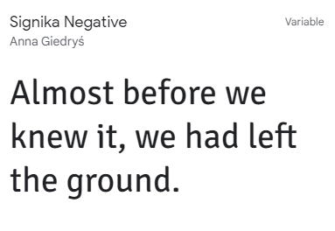

**Paleta de colores:**

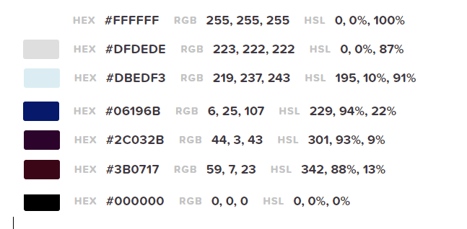

**Notas musicales:** [**http://diariopositivo2015.blogspot.com/2016/11/todas-las-notas-de-piano-en-mp3.html**](http://diariopositivo2015.blogspot.com/2016/11/todas-las-notas-de-piano-en-mp3.html)